Non-Isolated dc/dc Converters

The aim of the work is to design a converter which reduces 16V DC to 12V DC. The design options that we have for the task are Buck-Boost, Ćuk and SEPIC converter. The converter should be able to supply 24W at switching frequency of 50kHz. The output voltage ripple should not exceed 2%. In the end, which one is best solution for the application will be determined.

1. Buck-Boost Converter

**a)** Analytically determine the value of inductance for converter to be in CCM operation with 10% ripple current.

**b)** Analytically find the output capacitance value in order to have 2% output voltage ripple.

**c)** According to your calculations, find commercial products for inductors, capacitors and semiconductors from [Digikey](https://www.digikey.com/). State the parameters of devices. Explain your reasoning for selections.

**d)** Validate your results by constructing the designed buck-boost converter in Matlab/Simulink environment with non-idealities, meaning ESR values of capacitors and inductors, which you can find in the datasheets of the products. You can use ideal switching devices. Plot the following waveforms. Comment on the results and explain if you observe any discrepancy from analytical calculations.

* Output voltage
* Input current
* Inductance current

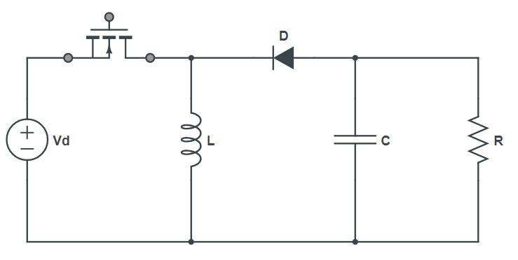

−

+

−

+

Figure 1. Buck-Boost Converter

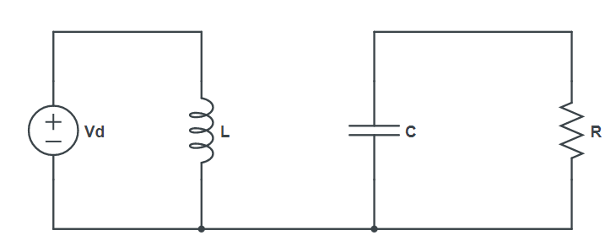

+

−

−

+

Figure 2. Buck-Boost Converter when S is ON

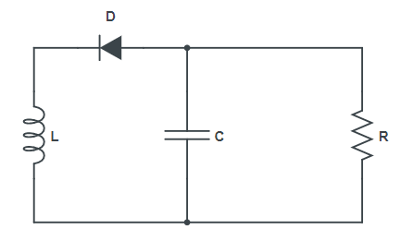

+

−

+

−

Figure 3. Buck-Boost Converter when S is OFF

∆

*Figure a: Inductor voltage waveform, Figure b: Inductor current waveform*

In properly designed converters, charging and decharging in the inductor current should be equal. Otherwise, the inductor current increases all the time and may damage to circuit.

Therefore, Area A and Area B should be equal each other and sum of these will cancel each other.

Put the values into the equation.

1. Analytically determine the value of inductance for converter to be in CCM operation with 10% ripple current.

1. Analytically find the output capacitance value in order to have 2% output voltage ripple.

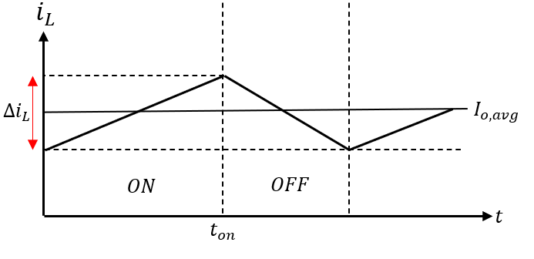

For first period () →

The output voltage ripple is given as 2%.

Therefore ,

1. According to your calculations, find commercial products for inductors, capacitors and semiconductors from [Digikey](https://www.digikey.com/). State the parameters of devices. Explain your reasoning for selections.

Capacitor and Inductor values were found in the previous pages. They are:

However, 1.38mH is not available for purchase. When the specifications are applied to search motor in Digikey, the possible inductor value is 2.2mH when the inductor current ratings are taken into account. Therefore, our inductor value will be 2.2mH.

The appropriate inductor is: [CTDR4F-222K](https://ctparts.com/product-spec/ctdr4f.pdf)

It has DC resistance (DCR) 0.494Ω

Cost: Does not specified. Assumed it is $3/unit

For the capacitor, the required specifications are entered in Digikey, it will show us available capacitors. One of them is: [16SEPF1000M](https://industrial.panasonic.com/ww/products/pt/os-con/models/16SEPF1000M) (Polymer Aliminum Solid Capacitor)

It has capacitance of 1mF, voltage rated of 16V, ESR of 12mΩ

Cost: ($2.32/unit)

For switching component, I preferred MOSFET. Which needs to have 30V voltage rate, and 4A current rate, which is available in Digikey

[DMG3418L-7](https://www.diodes.com/assets/Datasheets/DMG3418L.pdf)

Which has Rds(on) 60mΩ

Its price: $0.43

Diode has to be withstand 38V reverse. Average current flow through diode is 3.8A

Therefore, I chose 40V, 4A Schottky Diode for this purpose.

[SSB43L-E3/52T](https://www.vishay.com/docs/88884/ssb43l.pdf)

It has forward voltage (

Its price is $0.6

1. Validate your results by constructing the designed buck-boost converter in Matlab/Simulink environment with non-idealities, meaning ESR values of capacitors and inductors, which you can find in the datasheets of the products. You can use ideal switching devices. Plot the following waveforms. Comment on the results and explain if you observe any discrepancy from analytical calculations.

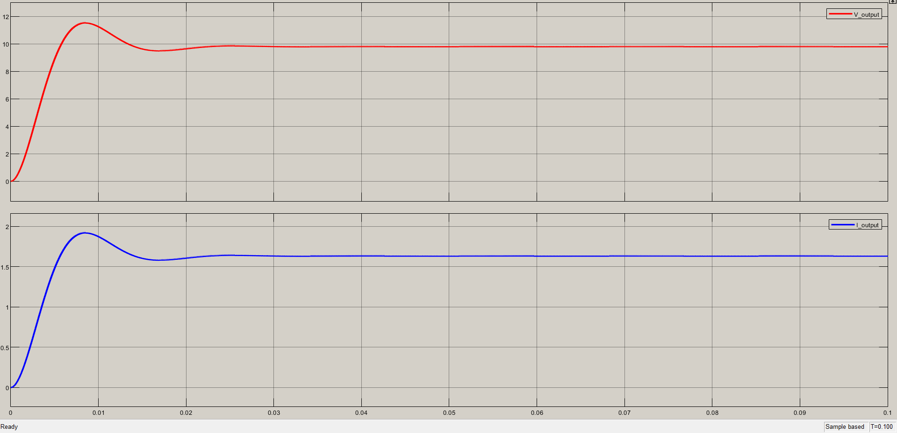

Figure 4. Buck-Boost Conerter with non idealities

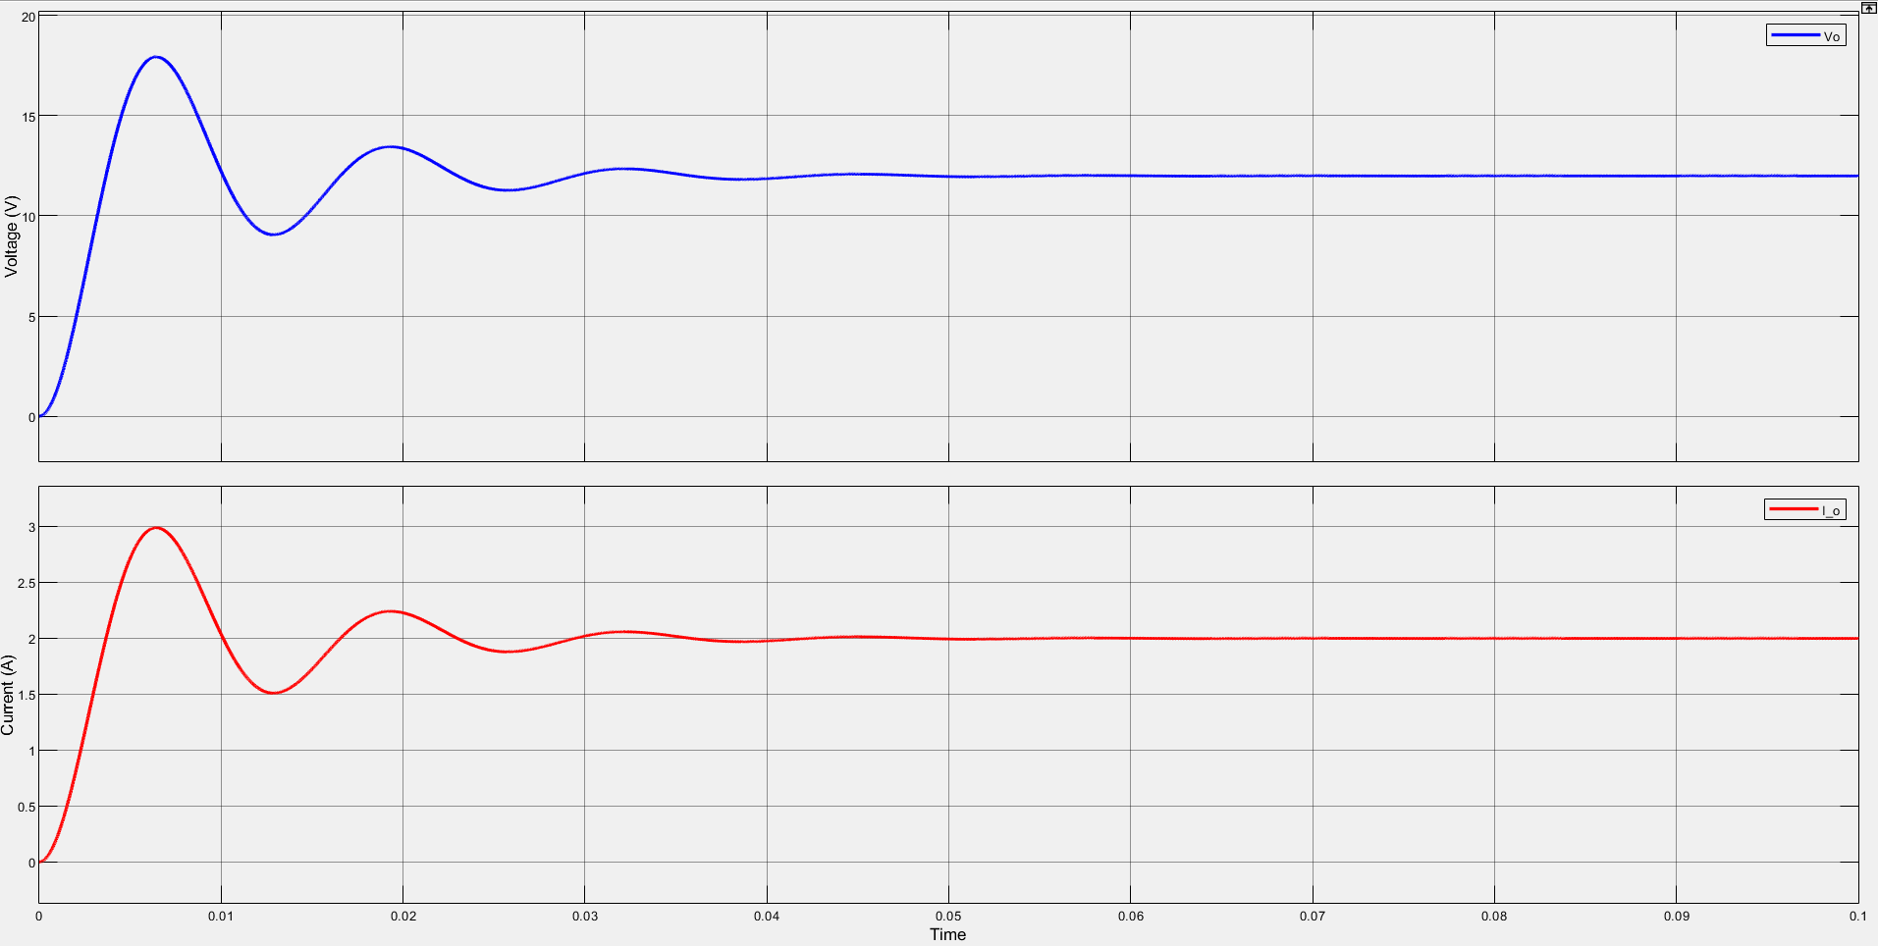

Figure 5. Buck-Boost converter ideal case

Here in both cases, duty ratio (D) are calculated as 0.45 or 45%. However, with non-idealities, with the same duty ratio (D), it could not reach desired output voltage values. Therefore, duty ratio (D) has to be increased.

With increase in duty ratio (D) +7%. That is, 52% duty ratio provides the following waveform:

Figure 6. Increase in duty ratio (D) = 52%

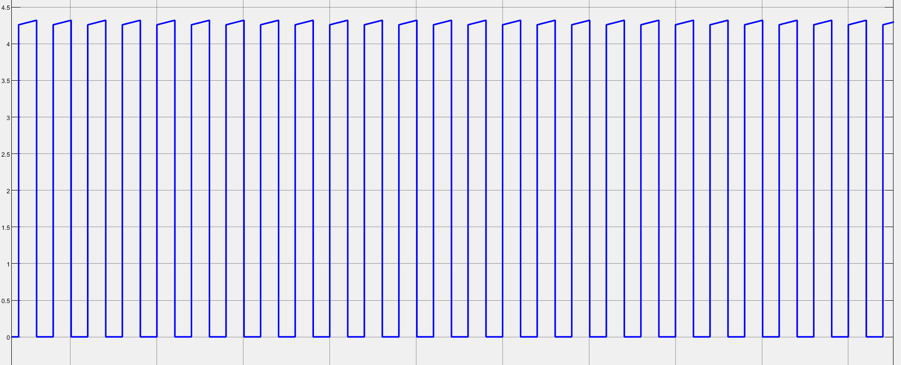

Figure 7. Input Current with non-idealities

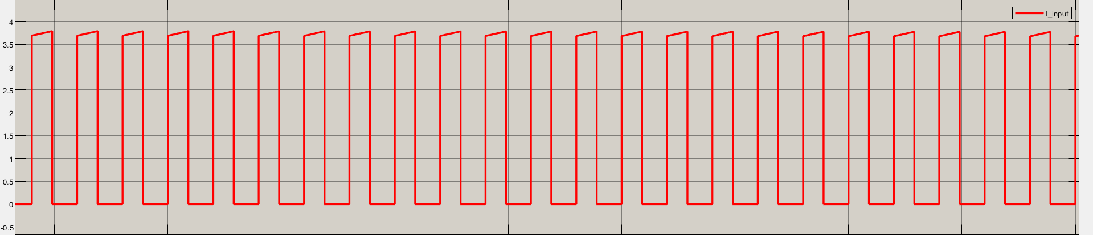

Figure 8. Input current in ideal case

As there are some power losses due to non-idealities, the duty ratio increased to ensure to get the same parameters. Therefore, with the increase in duty ratio (D), input current will be much higher than before. As it can be seen on the graphs above.

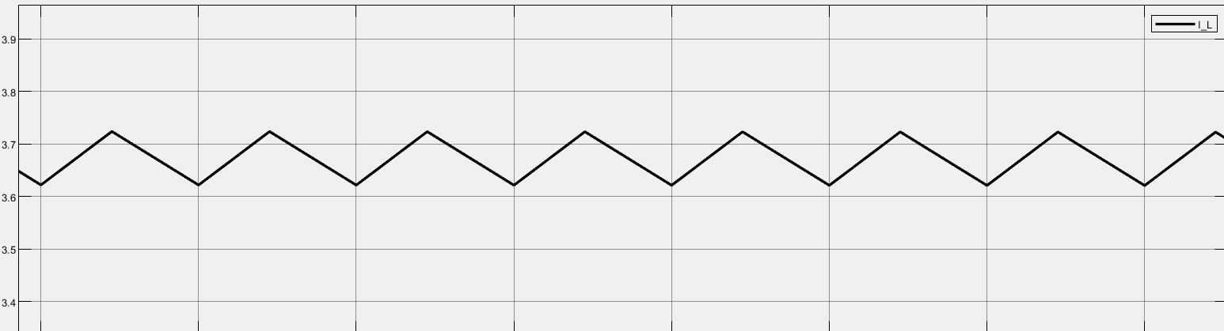

Figure 9. Inductor current in ideal case

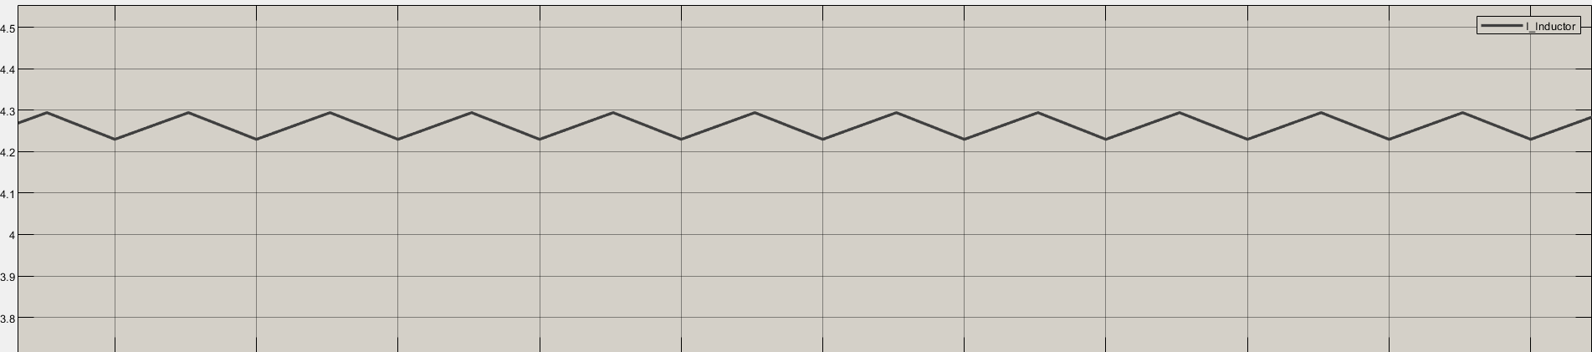

Figure 10. Inductor current with non-idealities

As the input current is increased with increase in duty ratio (D), the inductor current has also increased. However, as inductance is different and bigger than in ideal case, the current ripple in the inductor is decreased as expected.

There are some differences due to non-idealities like ESR of capacitor, inductor, or voltage drops in switching components. Also, on-resistances of the switching components.

1. Ćuk Converter Design

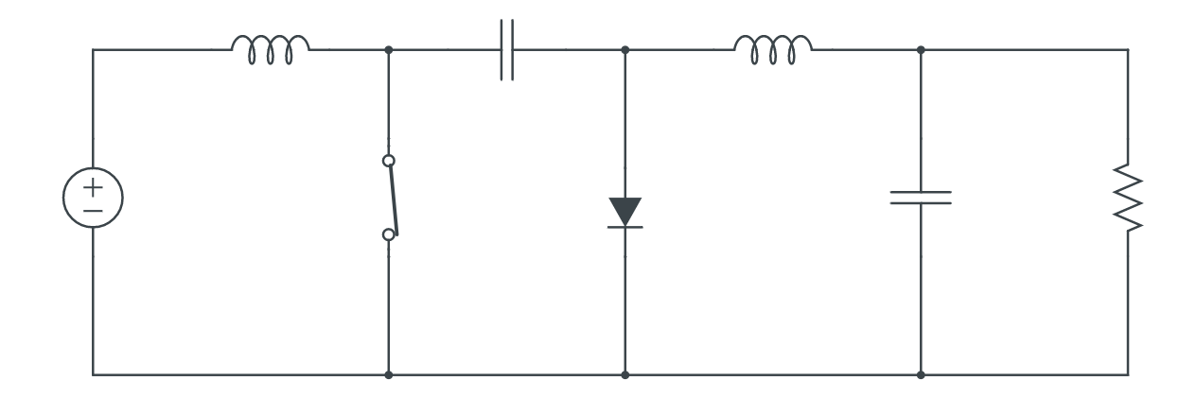

Figure 11. Ćuk converter circuit schematic

There are 2 modes in Ćuk converter, one is switch (Q) is ON and another one is switch (Q) is OFF.

OFF-State:

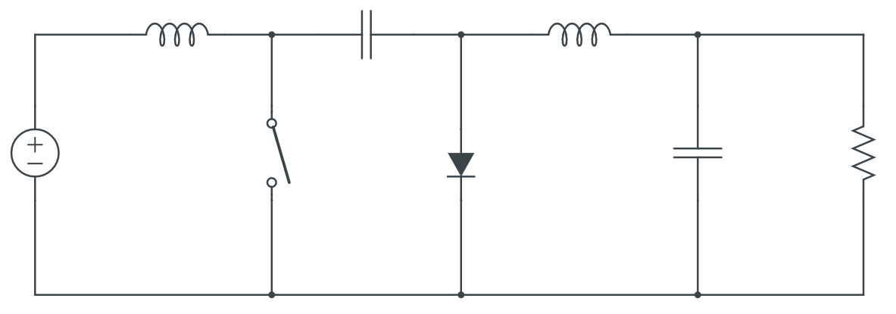

Figure 12. Switch (Q) is OFF

When the switch (Q) is OFF, & flow through the diode. The capacitor is charging through the diode by the energy from both & . Current decreases since >. Energy stored in feeds the output. Therefore, also decreases.

ON-State:

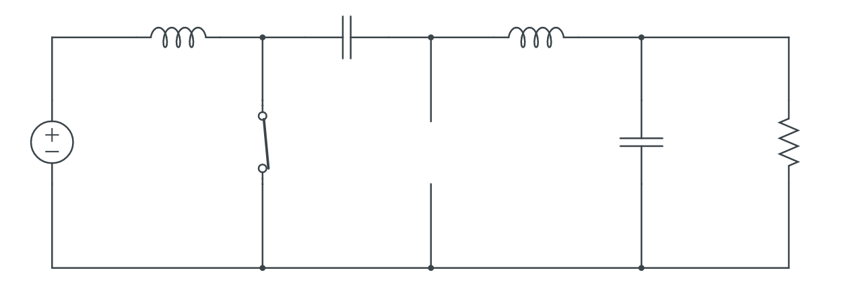

Figure 13. Switch (Q) is ON

As >, is discharging through the switch, transferring energy to the output & . Also, reverse biases the diode. Therefore,increases. The input source feeds causing to increase.

The inductor current & are assumed to be continuous. The voltage & current expressions is steady-state can be obtained in two different ways.

OFF-State

ON-State

From volt-second balance equation:

From volt-second balance equation:

From equation 1 & 2

Transfer function of Ćuk converter is

Where

Ćuk converter can be operated in both buck converter or boost converter depends on the duty cycle (D). However, output voltage is a negative. It is a inverting converter.

To recap, in the buck converter, discontinuous input current we have. In the boost converter, we have discontinuous output current, in the buck-boost converter we have discontinuous current on both the input as well as on the output side.

That means, we encounter such EMI problems in discontinuous converters. However, with the Ćuk converter, EMI problems can be minimized. If EMI problems are important for a design, Ćuk converter is a better solution for it.

1. Calculate the required output capacitor, C2 , value in order to have 2% voltage ripple, and find the values of L1, L2 inductances by assuming 10% ripple current.



Figure 14. Ćuk converter circuit schematic

It can be said that right side of the Ćuk converter is similar to buck converter as seen in above figure. Therefore, the voltage ripple at the output can be derived from buck converter:

To find the value of , should be known.

We assume we are in CCM

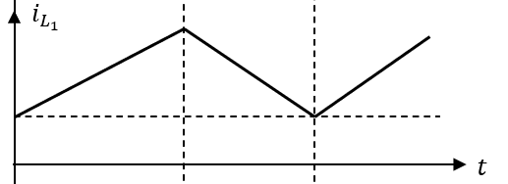

Ripple at the inductor currents was given as 10%.

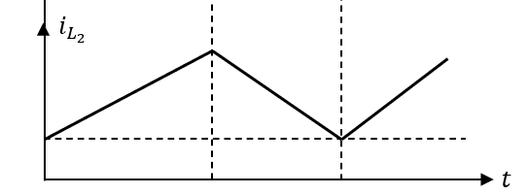

*The fact is ripple at the inductor currents are same, so inductor values should be same.*

Let’s assure that the converter is working at CCM.

For both ON and OFF-States

Therefore, CCM is verified.

Percentage error of the inductors:

For capacitor

1. Find the value of C1 capacitor by assuming 10% ripple voltage.

is found as 1.51A, is found as 2A, D = 0.43.

To ensure the value is correct, let’s calculate from D period.

As it supposed to be that

1. According to your calculations, find commercial products for capacitors, inductors and semiconductors from Digikey. State the parameters of devices. Explain your reasoning for selections.

The inductor values are same with the buck-boost converter, so the inductor found in the buck-boost design can be used for Ćuk converter.

The appropriate inductor is: [CTDR4F-222K](https://ctparts.com/product-spec/ctdr4f.pdf)

It has DC resistance (DCR) 0.494Ω

Cost: Does not specified. Assumed it is $3/unit

For

There is no available capacitance such 12.4. Therefore, the closest one is 20

[TE1090-E3](https://www.digikey.com/en/products/detail/vishay-sprague/TE1090-E3/5612596)

Rated Voltage = 6V, C = 20

No ESR specified

Price: $4.84/unit

For

should be able to handle which is 16V + 12V = 28V

In Digikey, 180 28V capacitor is not available; however, 180 35V is available for purchase.

[EEU-FR1V181B](https://www.digikey.com/en/products/detail/panasonic-electronic-components/EEU-FR1V181B/2504116)

ESR: 0.056Ω

Price: $0.68/unit

For MOSFET (Switch)

[DMG3418L-7](https://www.digikey.com/en/products/detail/diodes-incorporated/DMG3418L-7/4810932)

ESR = 70mΩ

Price: $0.43/unit

For Diode

[SK44BL-TP](https://www.digikey.com/en/products/detail/micro-commercial-co/SK44BL-TP/2642031)

Price: $0.45/unit

1. Construct the Ćuk converter in Simulink with non-idealities and check if the circuit meets the requirements. Plot the following waveforms. Comment on the results and explain if you observe any discrepancy from analytical calculations.

* Output voltage
* voltage
* currents

**Ideal Case:**

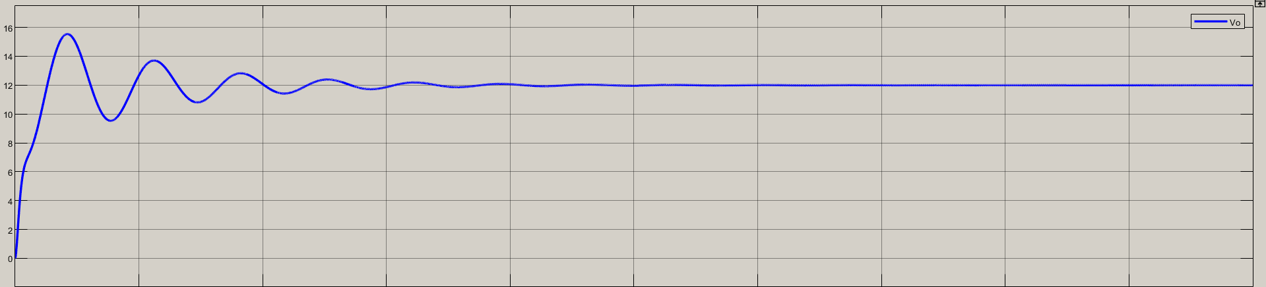

Figure 15. Output voltage waveform

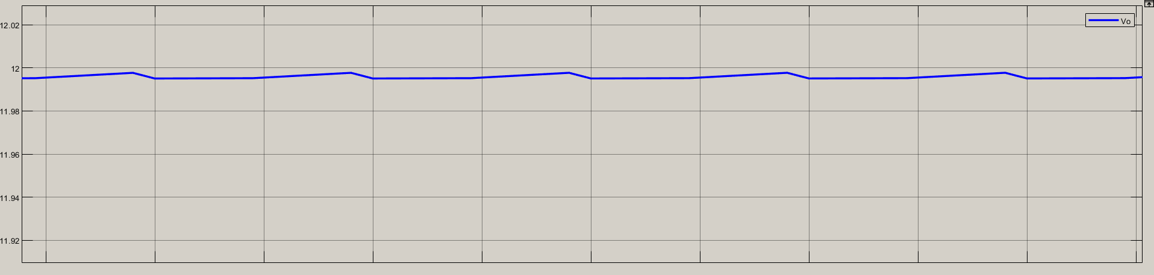

Figure 16. Output voltage ripple in ideal case

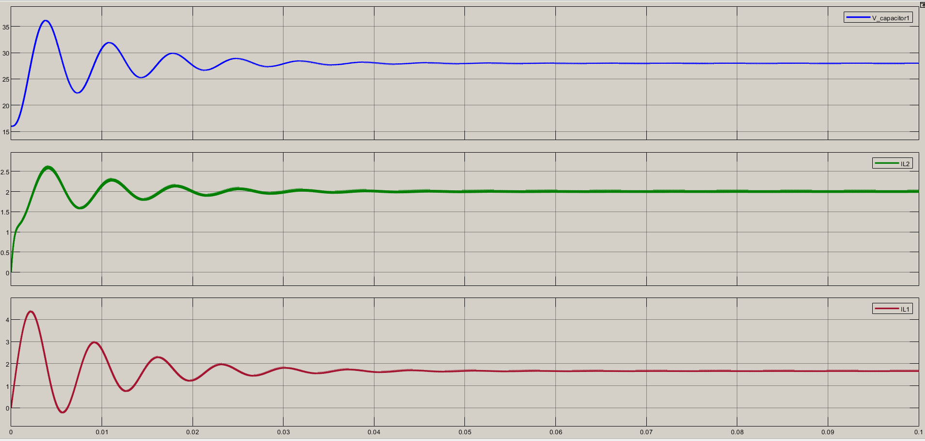

Figure 17. C1 voltage & L1, L2 currents waveforms in ideal case

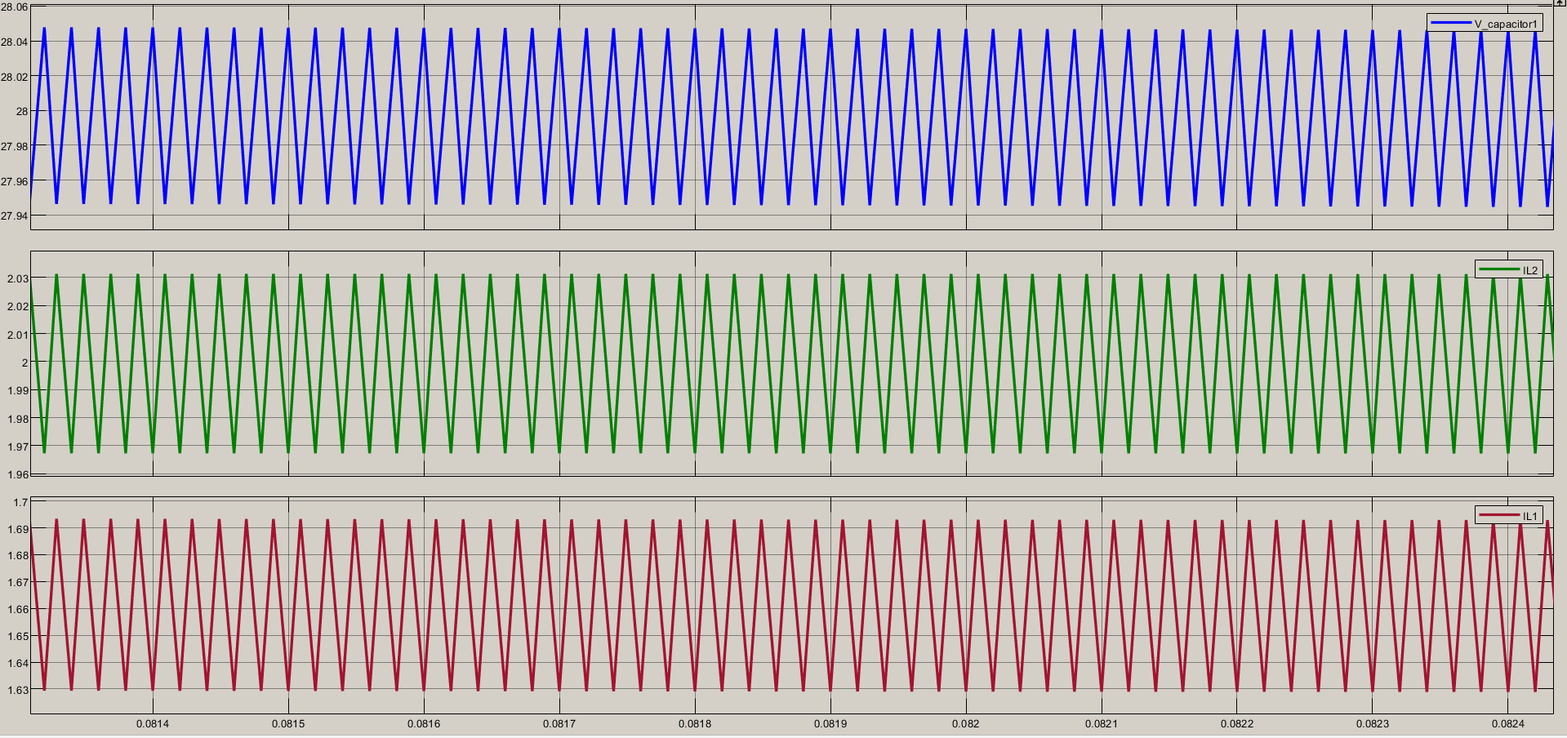

Figure 18. C1 voltage, L1 & L2 currents ripples in ideal case

**With Non-idealities**

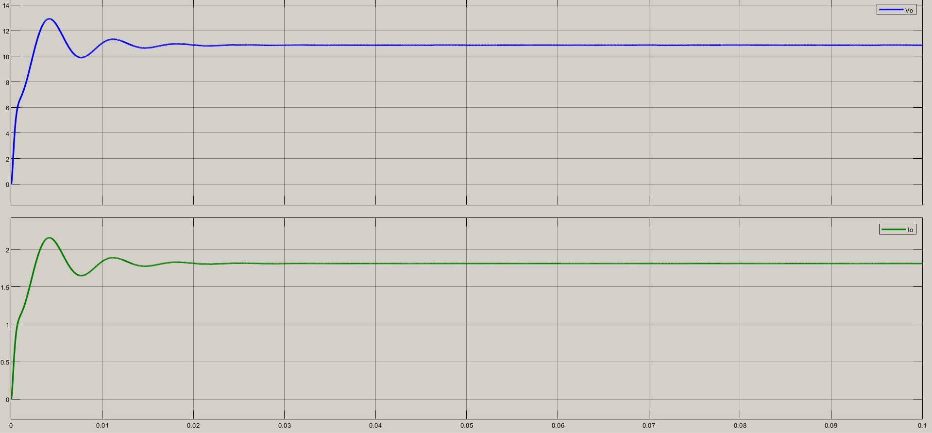

Figure 19. Output voltage & current waveform with non-idealities

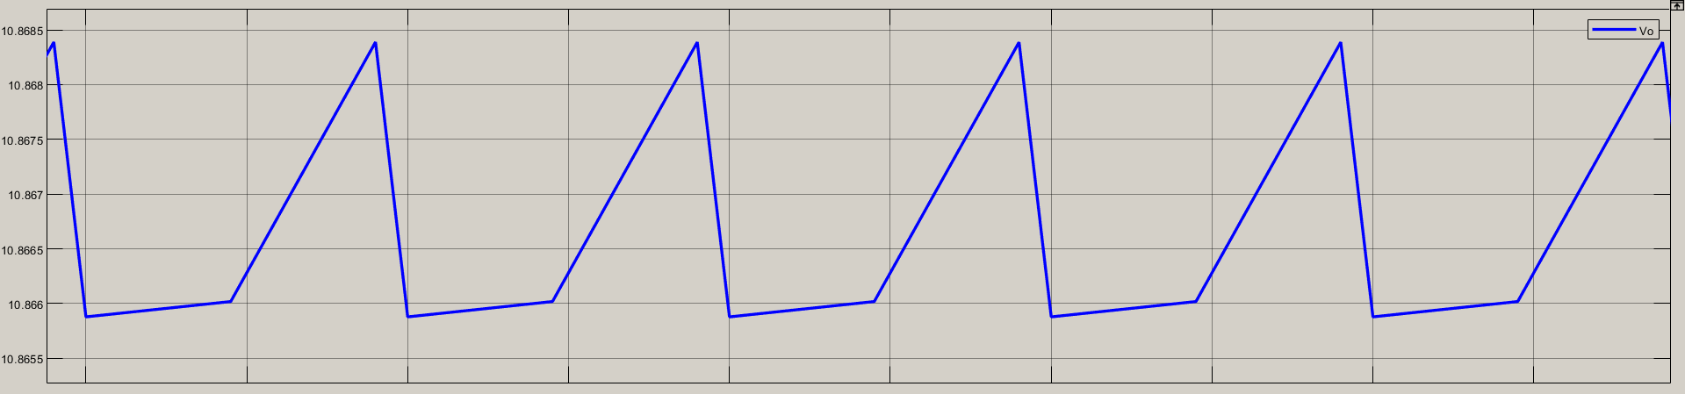

Figure 20. Output voltage ripple with non-idealities

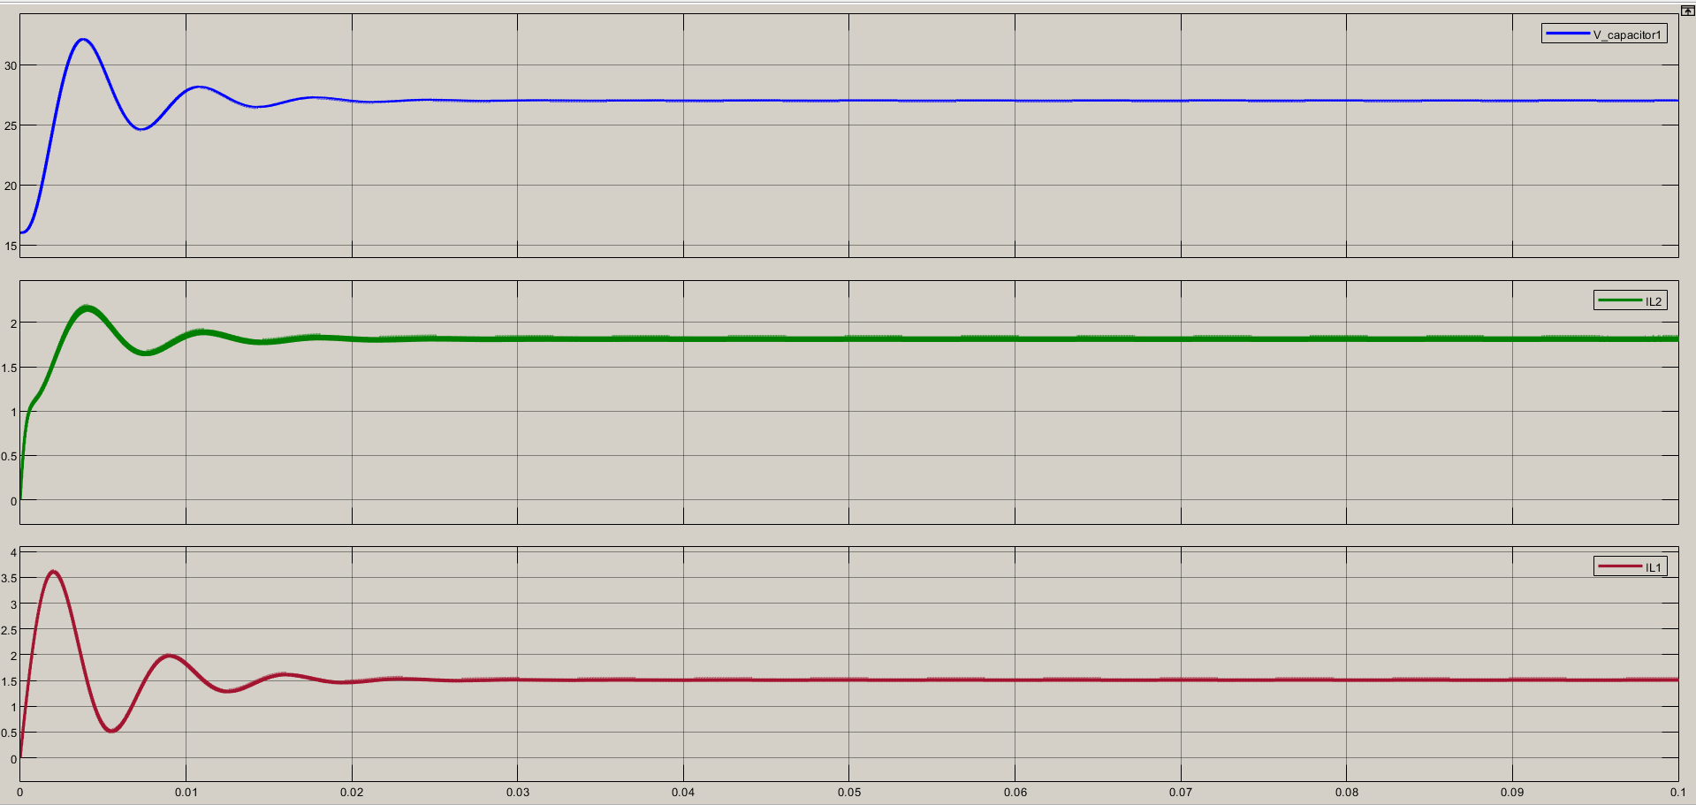

Figure 21. C1 voltage, L1 & L2 current waveforms with non-idealities

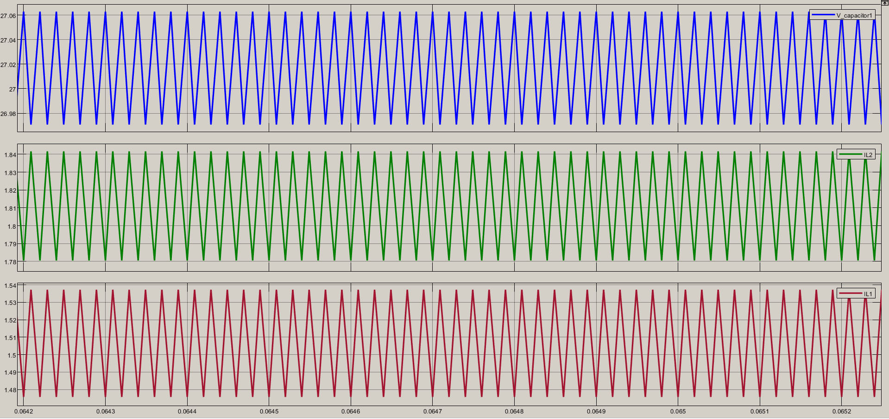

Figure 22. Voltage and current ripples on C1, L1 & L2 with non-idealities

**Results:**

The results are close to the desired specifications. However, losses in the components due to ESR or any other non-idealities, It is expected to reduce voltage drops across the load or components. However, it can be observed that the ripples will remain same because there is no change in capacitance or inductance values. However, duty ratio is increased to 48%. (Was 45% in ideal case). Also, we can say that the time to reach steady-state condition is reduced.

1. SEPIC (Single Ended Primay Inductor Converter)

−

+

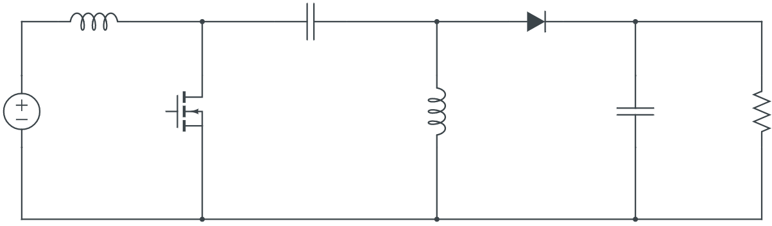

*Q*

−

−

−

−

+

+

+

+

Figure 23. SEPIC (Single Ended Primary Inductor Converter) circuit schematic

−

+

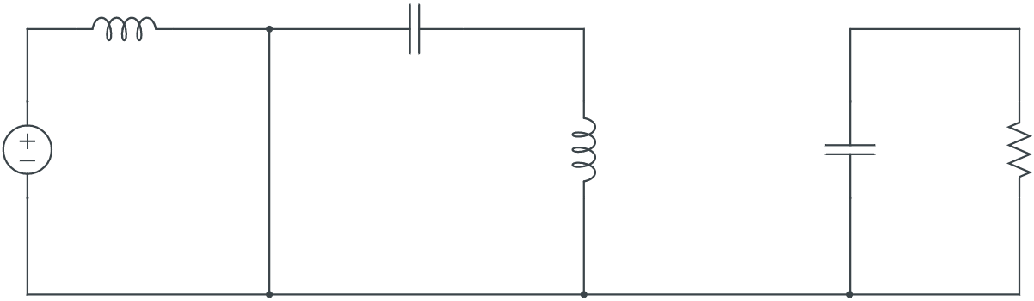

−

+

+

−

−

−

+

+

Figure 24. SEPIC ON-state circuit

−

+

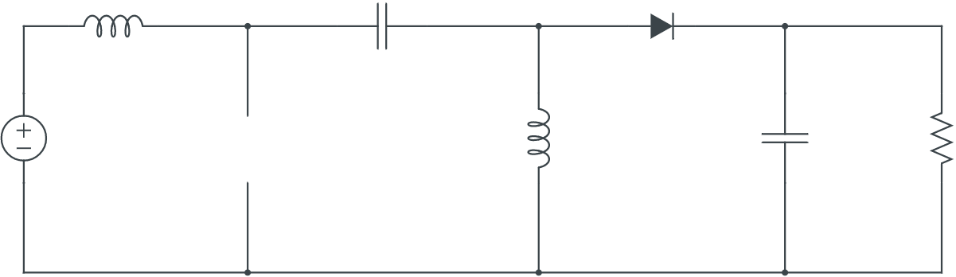

−

+

−

−

−

+

+

+

Figure 25. SEPIC OFF-state circuit

OFF-state:

To recap the equations:

ON-state:

During ON-state

From KVL:

Volt-second balance must remains:

Therefore;

Rewrite equation

During OFF-state

Rewrite equation:

Volt-second balance equation must be continued to remain safety of the circuit.

Therefore, area A & area B must be equal in magnitude and cancel each other.

It is same with Buck-Boost and Ćuk converter, but it is positive polarity at the output. In Buck-Boost and Ćuk, the converters have negative polarity at the output. Also, the difference here in SEPIC converter is ability to shutdown completely (When the switch is OFF).

Let’s see voltage & current waveforms to see the behaviour of the converter:

For , If Kirchhoff's Voltage Law is applied on the circuit below with yellow path:

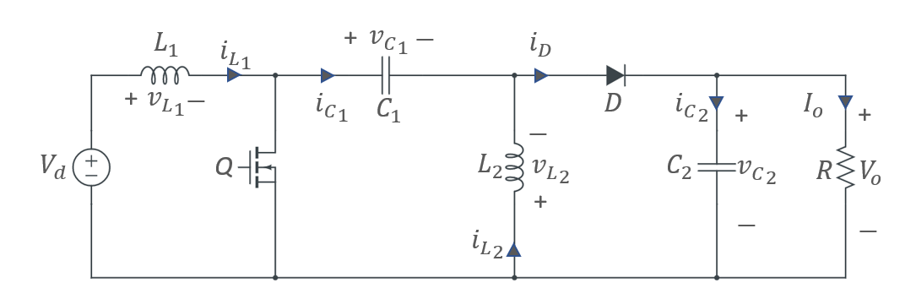

+

−

Figure 26. SEPIC is in OFF-state

As we found :

during OFF-state.

1. Calculate the required output capacitor, C2 , value in order to have 2% voltage ripple, and find the value of L1, L2 inductances by assuming 10% ripple current.

To calculate the inductors :

First, it is necessary to find duty ratio (D) first.

As it is found in the previous pages:

D = 0.43 or 43%

During ON-state (D):

&

To calculate values, we need to determine the current of the capacitor .

during ON-state

1. Find the value of capacitor by assuming 10% ripple voltage.

To find , capacitor current must be known.



Figure 27. SEPIC circuit schematic

KCL at the yellow point:

Substitute equation into equation:

It is known that steady-state operation the capacitor net charge or charge-second balance on a capacitor is equal to zero.

Therefore; average current through the capacitor is

Now, it is possible to calculate the capacitor

Because average value of is found, the way of calculation became easier.

Also, it is known that ripple at capacitor is 10%.

For switching components, Q needs to block positive voltage and positive current, D should block negative voltage and positive current. That means, Q can be IGBT, BJT or MOSFET. D is obviously is diode.

Q must block

D must block

To recap:

Because, the inductor values are the same with the previous topologies’ values, it is better to use same inductor to compare accurately.

The appropriate inductor is: [CTDR4F-222K](https://ctparts.com/product-spec/ctdr4f.pdf)

It has DC resistance (DCR) 0.494Ω

Cost: Does not specified. Assumed it is $3/unit

Capacitor

16V, 180μF

[860020373009](https://www.digikey.com/en/products/detail/w%C3%BCrth-elektronik/860020373009/5727033)

No ESR or ESL specified

Unit price: $0.16/unit

Capacitor

12V, 1000μF

[672D108F012DS5D](https://www.digikey.com/en/products/detail/vishay-sprague/672D108F012DS5D/5611975)

0.06 ESR specified.

Unit price: $5.5

For MOSFET (Switch)

[DMG3418L-7](https://www.digikey.com/en/products/detail/diodes-incorporated/DMG3418L-7/4810932)

ESR = 70mΩ

Price: $0.43/unit

For Diode

[DFLS220L-7](https://www.digikey.com/en/products/detail/diodes-incorporated/DFLS220L-7/700090)

Price: $0.23/unit

The simulation results are:

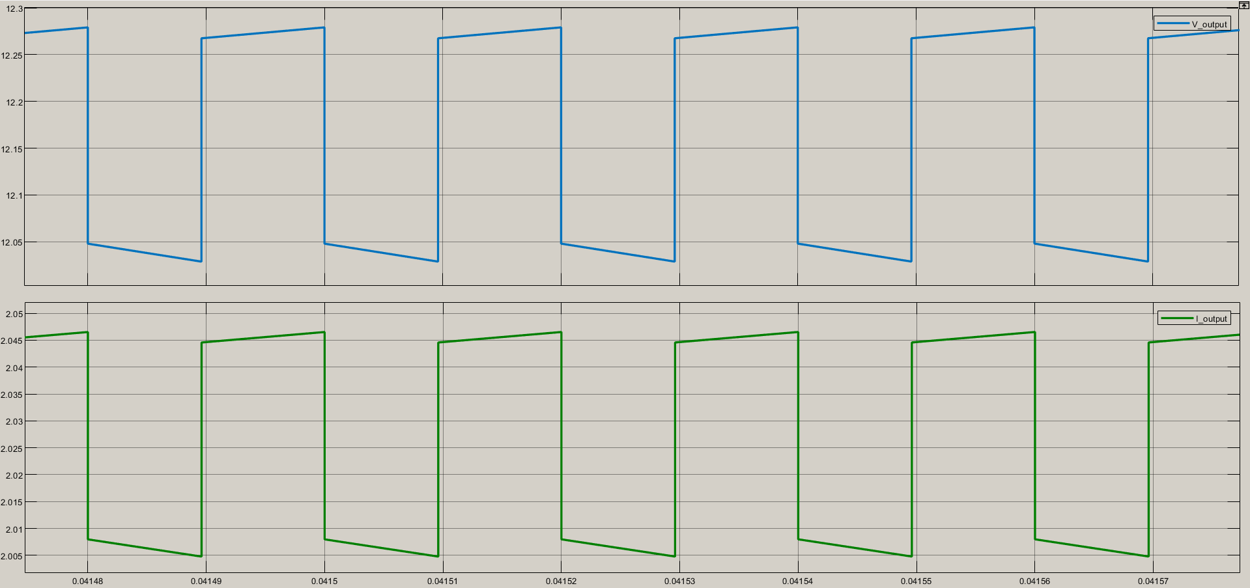

Figure 28. Output voltage and current waveform

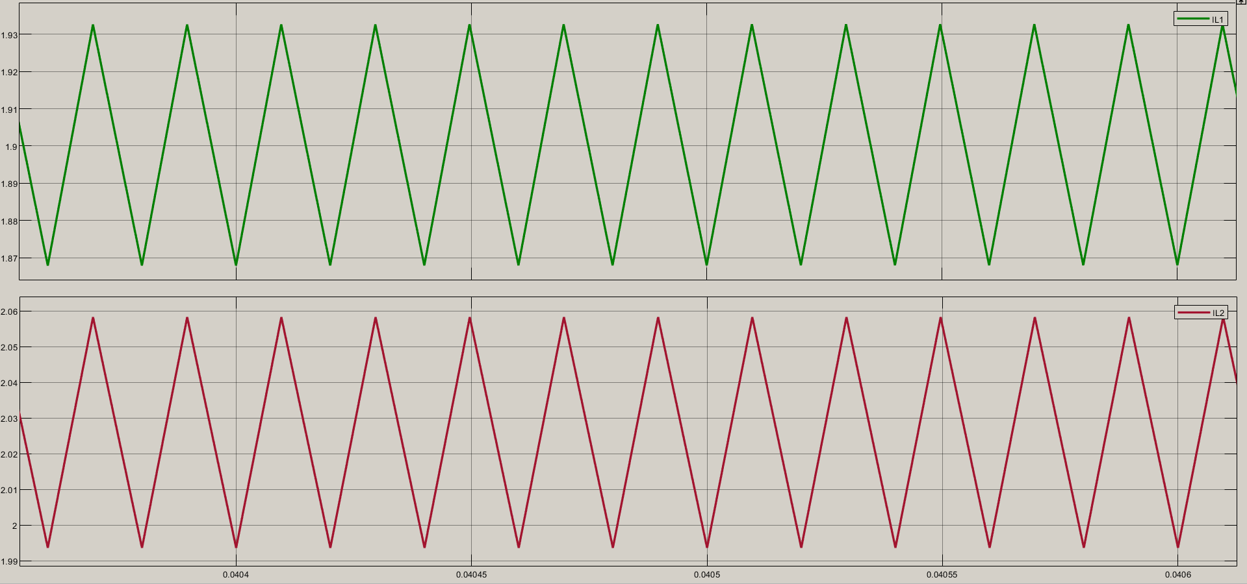

Figure 29. Inductor currents IL1 & IL2

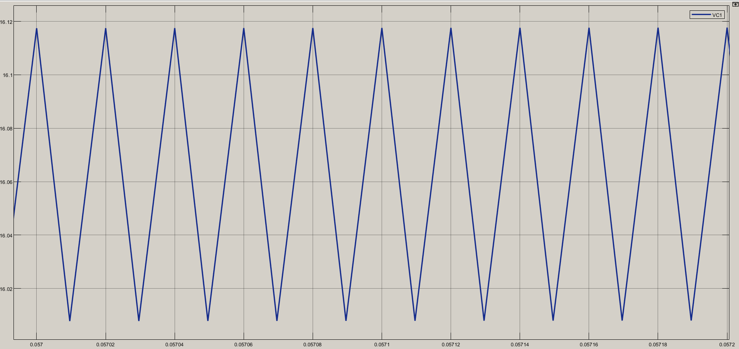

Figure 30. C1 voltage waveform

As it can be observed, all the specifications are met and in the given range. However, duty ratio (D) is not 43%, but 48% due to losses due to non-idealities. Therefore, duty cycle ratio has been increased.

1. Comparison between topologies
2. Create a table which shows all the circuit components that you have used in your design with their costs.

|  |  |  |  |  |  |  |  |  |
| --- | --- | --- | --- | --- | --- | --- | --- | --- |
| **Topology** | **Output Voltage Polarity** | **Switching Component** | **Diode** |  |  |  |  | **Total Price** |
| ***Buck-Boost Converter*** | − | [DMG3418L-7](https://www.diodes.com/assets/Datasheets/DMG3418L.pdf) | [SSB43L-E3/52T](https://www.vishay.com/docs/88884/ssb43l.pdf) | [CTDR4F-222K](https://ctparts.com/product-spec/ctdr4f.pdf) | [CTDR4F-222K](https://ctparts.com/product-spec/ctdr4f.pdf) | [16SEPF1000M](https://industrial.panasonic.com/ww/products/pt/os-con/models/16SEPF1000M) | × | **$9.35** |
| **Price** |  | **$0.43** | **$0.6** | **$3** | **$3** | **$2.32** | × |
| ***Ćuk Converter*** | − | [DMG3418L-7](https://www.diodes.com/assets/Datasheets/DMG3418L.pdf) | [SK44BL-TP](https://www.digikey.com/en/products/detail/micro-commercial-co/SK44BL-TP/2642031) | [CTDR4F-222K](https://ctparts.com/product-spec/ctdr4f.pdf) | [CTDR4F-222K](https://ctparts.com/product-spec/ctdr4f.pdf) | [EEU-FR1V181B](https://www.digikey.com/en/products/detail/panasonic-electronic-components/EEU-FR1V181B/2504116) | [TE1090-E3](https://www.digikey.com/en/products/detail/vishay-sprague/TE1090-E3/5612596) | **$12.4** |
| **Price** |  | **$0.43** | **$0.45** | **$3** | **$3** | **$0.68** | **$4.84** |
| ***SEPIC*** | + | [DMG3418L-7](https://www.diodes.com/assets/Datasheets/DMG3418L.pdf) | [DFLS220L-7](https://www.digikey.com/en/products/detail/diodes-incorporated/DFLS220L-7/700090) | [CTDR4F-222K](https://ctparts.com/product-spec/ctdr4f.pdf) | [CTDR4F-222K](https://ctparts.com/product-spec/ctdr4f.pdf) | [860020373009](https://www.digikey.com/en/products/detail/w%C3%BCrth-elektronik/860020373009/5727033) | [672D108F012DS5D](https://www.digikey.com/en/products/detail/vishay-sprague/672D108F012DS5D/5611975) | **$12.32** |
| **Price** |  | **$0.43** | **$0.23** | **$3** | **$3** | **$0.16** | **$5.5** |

1. According to your analytical calculations and simulation results, list the advantages and disadvantages of each converter topology and comment on the input current waveforms.

In Buck-Boost converter:

* Sharp edges on input currents create EMI problems
* Supplies a negative voltage. (Inverting converter)

In Ćuk Converter:

* Supplies a negative voltage (Inverting converter)
* Reduced EMI & bi-directional power flow
* should be large like (Disadvantage)
* Double-ended: Inductors placed at both the input and output side, therefore; the current on both side never goes to zero (no sharp edge)

In SEPIC:

* Supplies a positive polarity voltage
* Possible to shutdown completely (when the switch is OFF)
* Reduced EMI compared to Buck-Boost Converter
* Single-ended: An inductor placed in primary end, but not in the output end

1. Which one of these three topologies would you choose considering circuit components used in the circuit? Explain why did you choose that specific topology and why did not you choose other two topologies. What might be the case in which other two topologies are more suitable?

If EMI problems are being considered first, I will go through Ćuk converter, but If a needs to shutdown input source side completely and EMI is still being considered, it is better to go for SEPIC. However, If EMI problems are not considered and money should be the case, go for Buck-Boost converter.

MATLAB .slx files can be found in the repository.

Coprights are belonging to itself